# Department of Computing

# CS361: Computer Graphics

# Class: BSCS-2AB & BESE-3AB

# Lab04: Animations

# Date: 28th September, 2015

# Time: 2:00pm- 5:00pm

# Instructor: Dr. Muhammad Muddassir Malik

# Lab 4: Animations

# Introduction

Computer graphics methods are now commonly used to produce animations for a variety of application including entertainment (motion pictures and cartoons), advertising scientific and engineering, studies and training and education.

**Objectives**

After performing this lab students should be able to create basic:

Animations

**Tools/Software Requirement**

For testing HTML 5, CSS, JS

**Description**

**Mouse Events**

[**http://www.homeandlearn.co.uk/JS/html5_canvas_mouse_events.html**](http://www.homeandlearn.co.uk/JS/html5_canvas_mouse_events.html)

**Task1:**

Draw the picture as shows in the following image (diagram 1). You must implement and use a model view matrix stack. All the vertices should be in a single vertices array. **[4]**

**Task2:**

Write code so that the user should be able to change the location of the picture drawn in Task 1 using mouse click or click and drag. **[3]**

**Task3:**

Make the changes in the drawing such that it looks as in diagram 2. Perform the following animations:

* The two green lines and the 8 triangles are rotating constantly [1]
* The yellow rectangles on the top left and bottom right are moving to and fro horizontally as depicted by the lines. [1]
* Animation speed of the rectangles mentioned in the above point can be controlled by a slider. [1]

* Ignore the outline around the shapes and the colors of the like the squares and the triangles. You need to draw the triangles and squares in a single solid color without boundaries.

**Diagram 1 Diagram 2**

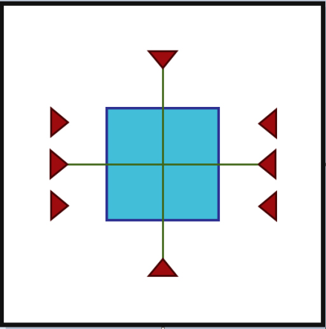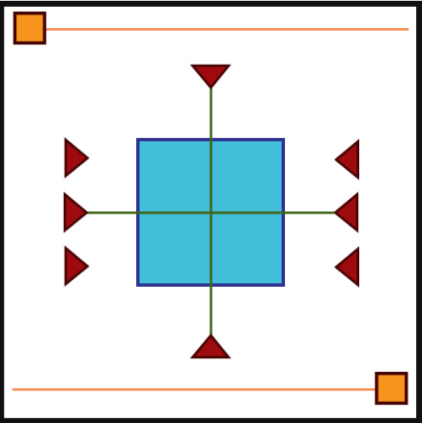

**Deliverable**

Upload your code with snap shots of the output.